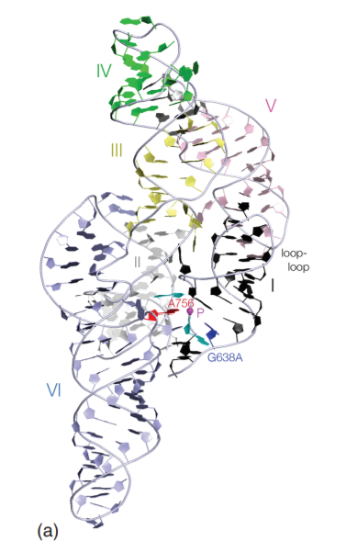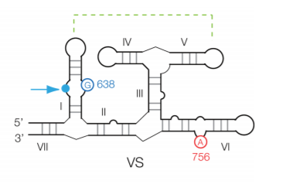

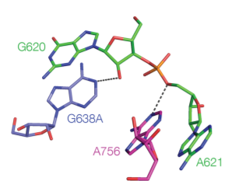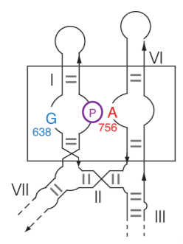

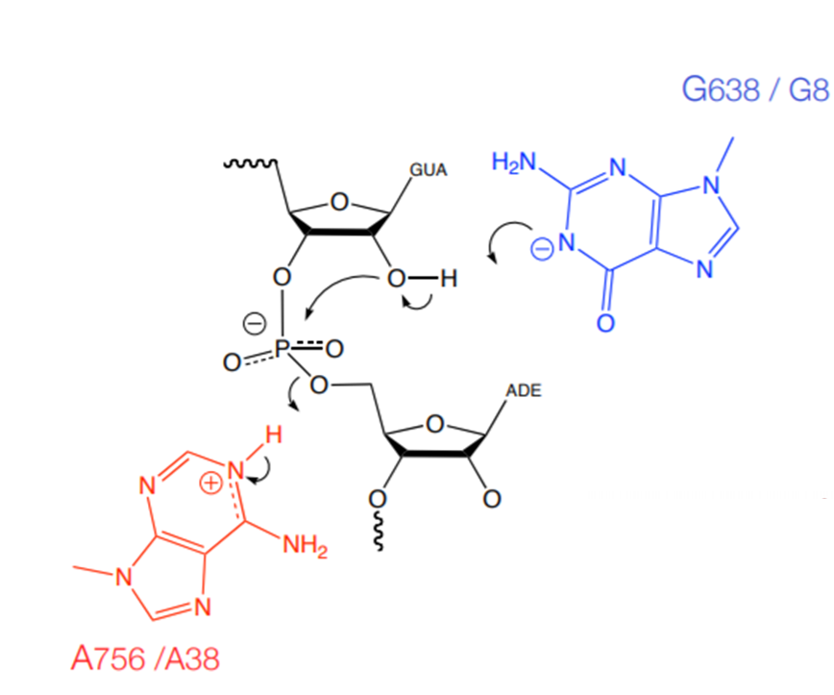

Catalytic mechanisms

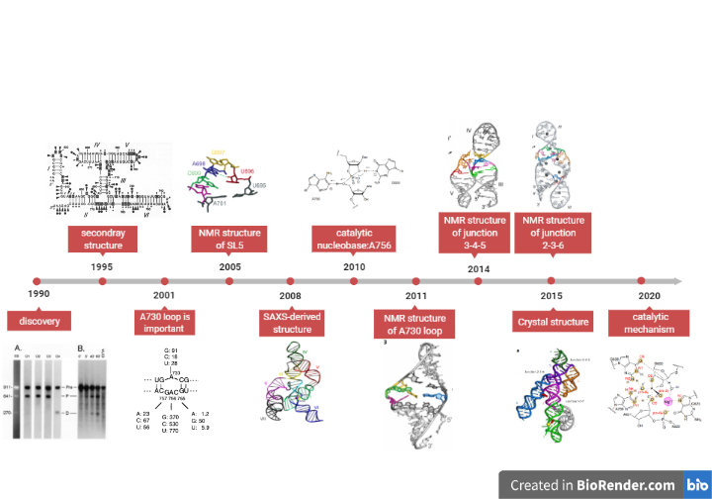

**Time line of VS ribozyme**

1. Saville B J,Collins R A,A site-specific self-cleavage reaction performed by a novel RNA in Neurospora mitochondria.[J] .Cell, 1990, 61: 685-96.
2. Beattie T L,Olive J E,Collins R A,A secondary-structure model for the self-cleaving region of Neurospora VS RNA.[J] .Proc Natl Acad Sci U S A, 1995, 92: 4686-90.
3. Lafontaine D A,Wilson T J,Norman D G et al. The A730 loop is an important component of the active site of the VS ribozyme.[J] .J Mol Biol, 2001, 312: 663-74.
4. Campbell Dean O,Legault Pascale,Nuclear magnetic resonance structure of the Varkud satellite ribozyme stem-loop V RNA and magnesium-ion binding from chemical-shift mapping.[J] .Biochemistry, 2005, 44: 4157-70.
5. Lipfert Jan,Ouellet Jonathan,Norman David G et al. The complete VS ribozyme in solution studied by small-angle X-ray scattering.[J] .Structure, 2008, 16: 1357-67.
6. Wilson Timothy J,Li Nan-Sheng,Lu Jun et al. Nucleobase-mediated general acid-base catalysis in the Varkud satellite ribozyme.[J] .Proc Natl Acad Sci U S A, 2010, 107: 11751-6.
7. Desjardins Geneviève,Bonneau Eric,Girard Nicolas et al. NMR structure of the A730 loop of the Neurospora VS ribozyme: insights into the formation of the active site.[J] .Nucleic Acids Res, 2011, 39: 4427-37.
8. Bonneau Eric,Legault Pascale,Nuclear magnetic resonance structure of the III-IV-V three-way junction from the Varkud satellite ribozyme and identification of magnesium-binding sites using paramagnetic relaxation enhancement.[J] .Biochemistry, 2014, 53: 6264-75.
9. Bonneau Eric,Girard Nicolas,Lemieux Sébastien et al. The NMR structure of the II-III-VI three-way junction from the Neurospora VS ribozyme reveals a critical tertiary interaction and provides new insights into the global ribozyme structure.[J] .RNA, 2015, 21: 1621-32.
10. Suslov Nikolai B,DasGupta Saurja,Huang Hao et al. Crystal structure of the Varkud satellite ribozyme.[J] .Nat Chem Biol, 2015, 11: 840-6.
11. Ganguly Abir,Weissman Benjamin P,Giese Timothy J et al. Confluence of theory and experiment reveals the catalytic mechanism of the Varkud satellite ribozyme.[J] .Nat Chem, 2020, 12: 193-201.